**Login**: admin login in dashboard to management

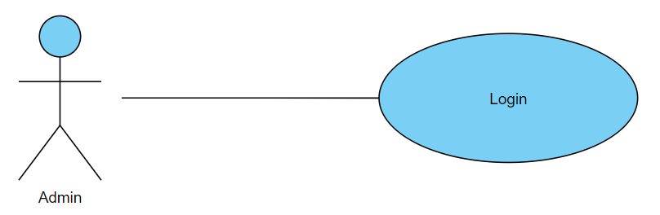

**Patients' Profiles**: management: admin management to patient profiles

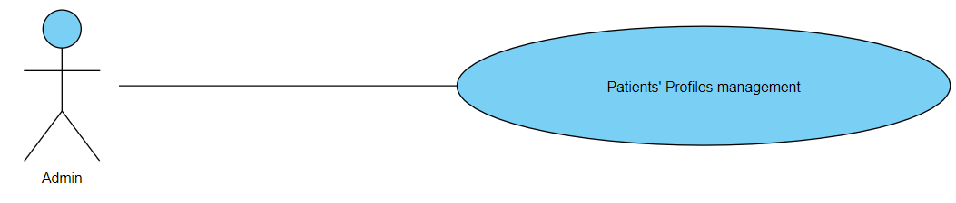

**Create User:** admin can create new patient account

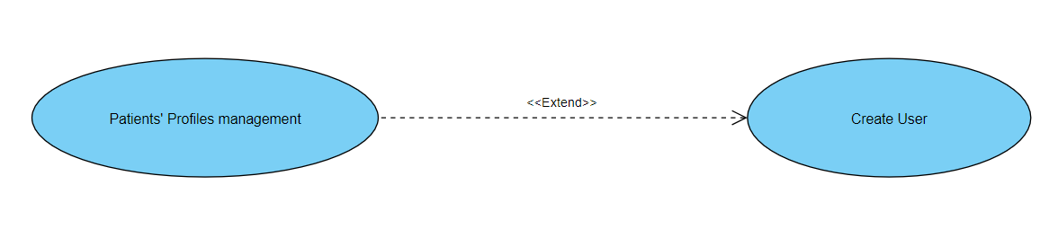

**Delete User:** admin can delete patient account

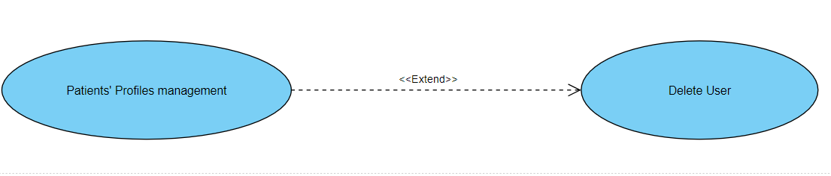

**Doctors' Profiles**: management: admin management to doctors’ profiles

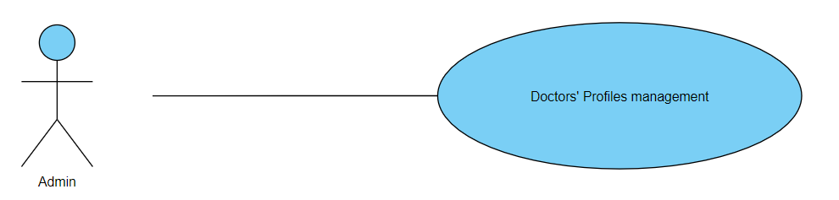

**Create User:** admin can create new doctor account

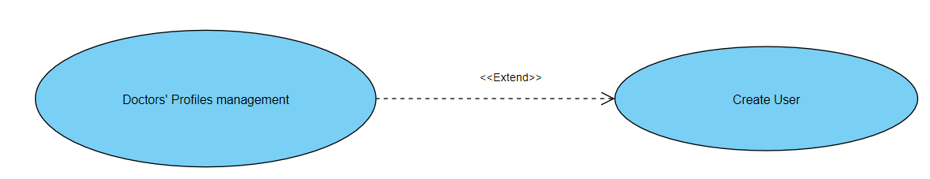

**Delete User:** admin can delete doctor account

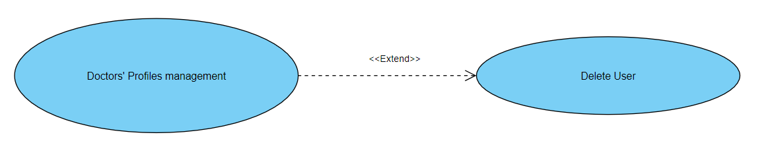

**Verify accounts** admin accept and verify new doctor account:

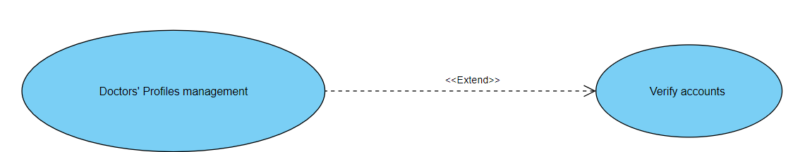

**Data management**: admin make management to data that come from all users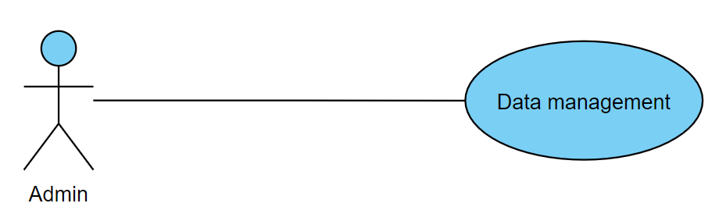

**Check data integrity:** admin check data that come from users

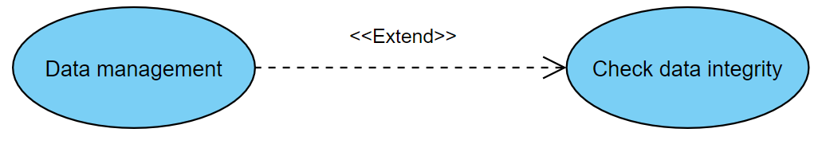

**Backup data**: admin make back up data

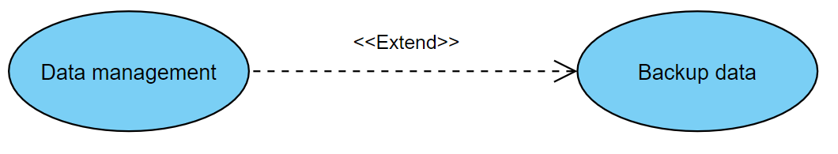

**Restore data;** admin make restore data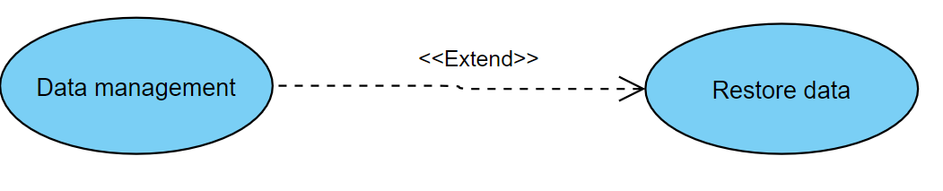

**System maintenance:** this use case include all system maintenance processing

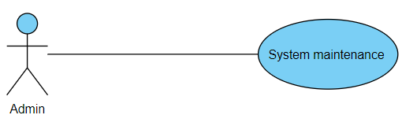

**Software update**: system maintenance processing include software update process

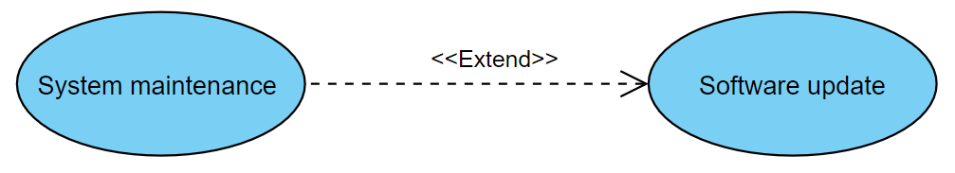

**Manage server:** system maintenance processing include Manage server

